Project Design Draft

1. **Design updates**

Our Iguana Squad team have made an update to the previous project design to allow us to focus on a system that scans the environment to precisely identify green iguanas and incorporates different features to detract the animal once detected.

The main component of the system is connected to a local hub that pairs with individual devices which includes a fixed camera and an infrared motion detector. It will have software capable of analyzing images and performing iguana recognition. Once the animal is identified, it will connect to speakers covering the perimeter of the facility and it will emit a low frequency sound to detract the animal and make it leave the area.

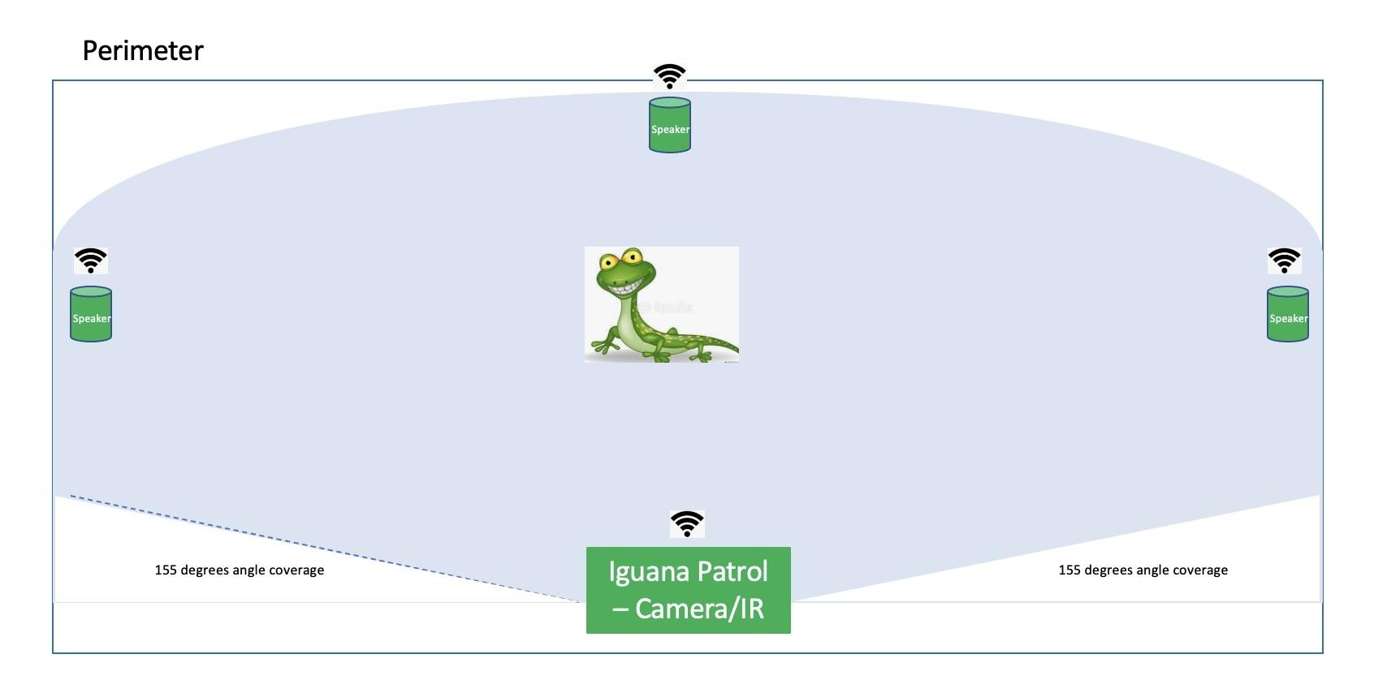

1. **Features included in revised design**
2. Iguana Patrol is connected to a local hub that is compatible with Alexa and Apple HomeKit to allow integration with the existing infrastructure.
3. A thermal infrared motion detector that measures the temperature of objects based on captured infrared energy. Although iguanas are cold blooded creatures, thermal imaging cameras paired with a high-resolution camera can help successfully locate and identify an iguana because these animals maintain a slightly higher temperature throughout the day, allowing the heat sensors to pick up on them.
4. A fixed high-resolution, wide-angle camera that captures images of the environment and maps the object once it is prompted by the thermal sensor that a target has been located.
5. Iguana recognition: Similar in technology to human facial recognition, our system will use artificial intelligence to detect green iguanas based on the information extracted from the captured images and its comparison to iguana biometric data on the cloud service.
6. A cloud service that contains iguana biometric data to enable object analysis.
7. Speakers that will activate an alarm at 3000hz to ward off the animal when it is detected. Iguanas can be sensitive to sounds at this frequency and will be startled to hear it unexpectedly.
8. Active/passive customization options: A user will be able to customize what methods of surveillance can be used at certain time intervals by an app.
9. **Updated Class Model Diagram**

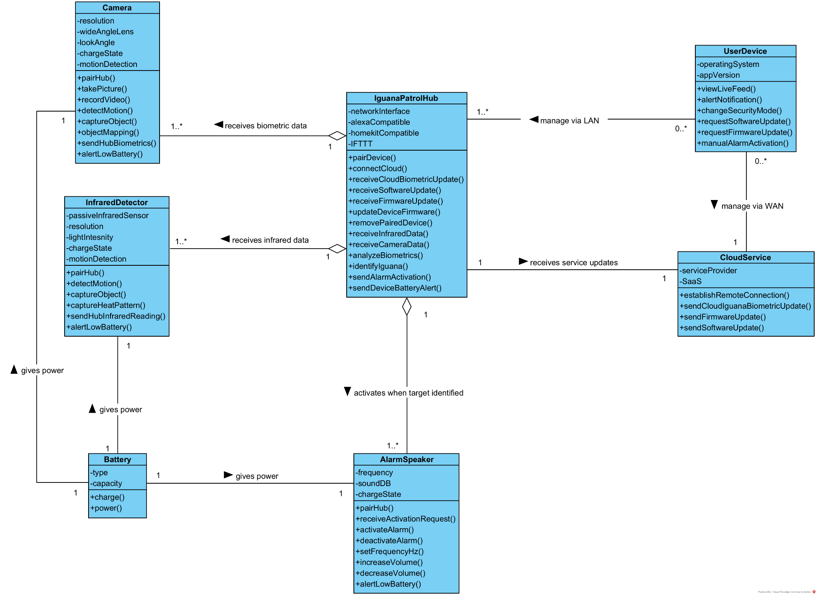

1. **State Diagram**

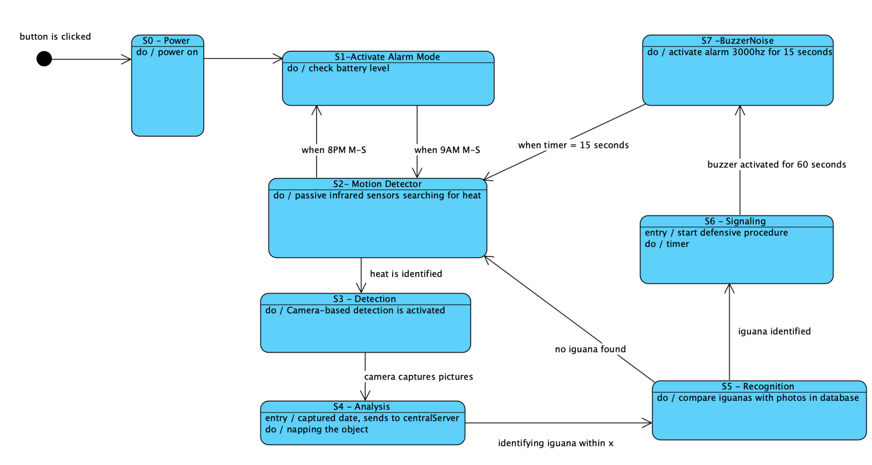

1. **Sequence Diagram Draft**

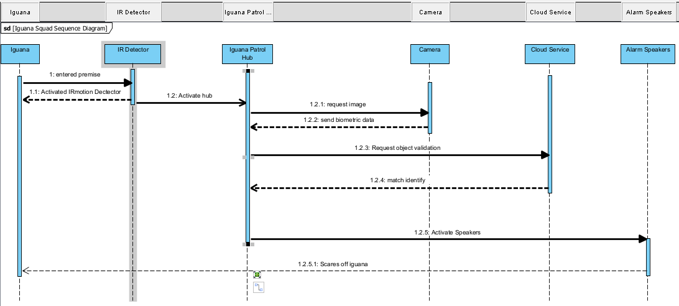

1. **Roles and responsibilities**

Michael, Product Manager/Owner - updated class diagram

Bilal, Software Developer - research

Alanis, Business Analyst - state diagram

Francisco, Scrum Master - state diagram

Nicole, Systems Tester - written specifications document

Dernard, Quality Analyst - research and sequence diagram draft

1. **Github**

https://github.com/mlaroccaFIU/IguanaPatrol